SCHOOL PROSPECTUS
2025/2026

Developing Responsible Citizens, Confident Individuals and Independent Learners


Britannia Primary School and Nursery
Britannia Road
IPSWICH
IP4 5HE

Web: www.britannia.suffolk.sch.uk
Email: office@britannia.suffolk.sch.uk
Phone: 01473 728566

Principal: Mr Keith Hart

CONTENTS

3 Welcome and Our Vision
4 Organisation and Admissions
5 Health and Safety
8 Attendance
9 Pupil Behaviour
10 School Uniform
11 Personal Belongings
12 Food and Drink
13 Parents in Partnership
14 Charges
15 The Curriculum
18 Children with Special Needs and EAL Pupils
19 Pupil Activities, Transfer to High School, Care out of School Hours
20 Complaints

The information and particulars contained in this prospectus relate to the current school year and are correct at the time of publication.
It should not be assumed that there will be no change affecting the relevant arrangements or some matter particularised-

- before the start of, or during, the school year in question, or
b) in relation to subsequent school years.

WELCOME

If your child is due to start school for the first time you will be invited to an induction session. We hope you will take full advantage of this programme. If your child is transferring from another school then you are welcome to arrange a visit to the school and meet the Principal. Please contact the school office for an appointment to visit.
On admission to Britannia Primary School, parents will be offered an interview time to discuss the details on the admission form and meet either the Principal, Vice Principal or Nursery Teacher.

Mr K Hart – Principal

OUR VISION, VALUES AND AIMS

‘Developing Responsible Citizens, Confident Individuals
and Independent Learners’

Responsible citizens
- Nurture respect for themselves, others and the environment.
- Build relationships and a learning culture of collaboration and sharing.
Confident Individuals
- Have the courage to take risks and the resilience to cope with challenge.
- The belief in their own capability to influence their own futures.
Independent Learners
- Enable learning capacity to flourish by recognising all children as active learners, capable of being resourceful, given supportive conditions.
- Plan experiences and opportunities that promote creativity through a curriculum rich in the arts, science and technology, humanities, spiritual, physical and emotional health, mathematics, language and citizenship
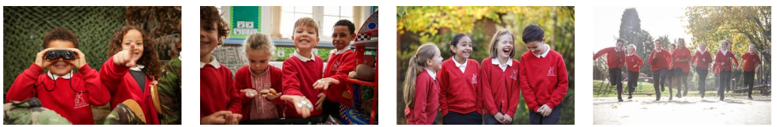

THE ORGANISATION OF OUR SCHOOL

Britannia is a Primary School for children aged 3 – 11 years, with a purpose-built Nursery on site. There are three classes in each age group containing children of mixed ability. We welcome children from varying cultures and those with disabilities, in so far as the school is equipped to cater for their specific needs. Children are usually taught within their own class group by their teacher, who is responsible for the day-to-day organisation and pastoral care of each individual child. Each phase has a Phase Leader, who co-ordinates the classes within their phase and has an overall organisation and pastoral role.

ADMISSIONS POLICY

The Local Authority (LA) is the admissions authority for Britannia. Their procedure is set out in the Suffolk Schools’ admission booklet published each year. You are required to state your preferred schools in rank order on the admission form. If the LA cannot meet your request, you have a right of appeal. To apply you can either complete a CAF form, which can be collected from any school, or you can apply online at the address below. All applications for admission must be received by the date published in the ‘Schools in Suffolk’ brochure. The admission limit for Britannia, agreed with the LA, is 90 pupils in each year group.
https://www.suffolk.gov.uk/children-families-and-learning/schools/school-places
It is important to note that, if you are successful in securing a place at Britannia for your child, this does NOT guarantee a place for a sibling.

Admission Arrangements for Nursery and Reception classes
Application forms for admission to the Nursery class are available from the school office. Completed forms should be returned to the school office.
Admission to the school’s nursery does not guarantee a place in the Reception class and application for the Reception intake has to be completed separately as outlined above.
The nursery offers places to three- and four-year-olds.
Children are admitted into one of the Reception classes the year in which they are five years old. You may choose a part time or full-time place for one, two or three terms or defer acceptance until your child is of statutory school age.

The Nursery and Reception classes provide a variety of learning opportunities which the children access through first-hand experience, investigation, imaginative play and creative involvement following the early years foundation stage curriculum (EYFS).
Both the Nursery and the EYFS areas are purpose built with a carpet area, quiet area and an indoor wet area. There are kitchen facilities and fully equipped toilets. There are outdoor play areas with hard surfacing, grass and trees. This offers a pleasant environment in which to play and learn.

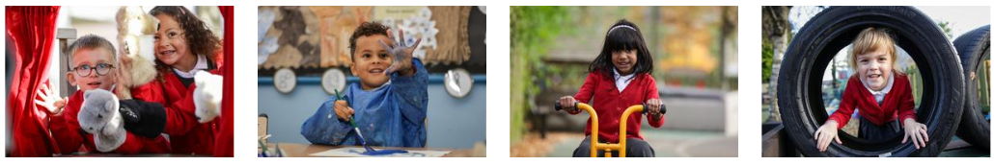

HEALTH & SAFETY

Britannia Primary School and Nursery is committed to safeguarding and promoting the welfare of children and young people. The school Safeguarding Policy outlines our duty of care to ensuring that every registered pupil at our school is safe and protected. The name of our Designated Safeguarding Lead (DSL) is Emma Campbell. There are Alternate Designated Safeguarding Leads (ADSLs) in each phase in school.

On the admission form, you will be asked to provide the school with your child’s relevant medical information. You are also asked to name an emergency contact. It is important that this information is kept up to date. Please make sure you notify the school office of any changes.

Illness in School
If a child has an accident or is taken ill, our first aim is to reassure the child and make them feel comfortable. In cases where we feel it best, parents will be contacted by telephone so that the child may be taken home or given further medical treatment. We always advise parents where their child receives a minor injury and appropriate treatment by issuing a ‘bump’ note. Calls home will be made for every head injury. If the accident or illness is serious then it is school policy to seek medical advice quickly. In all cases of emergency, the Principal will endeavour to get in touch with the parents concerned, but if this is not possible, he will act on the advice of the Medical Officer consulted.
A pupil may return to school with a broken limb in plaster and we can organise supervision at break and lunch times.
Medicines
When children are ill, it is the parents’ responsibility to ensure they receive proper care. The administering of medicines to children is also the responsibility of parents. The school will not accept responsibility for the administration of medicines but if a child requires medication during the day, parents are welcome to come into school and personally administer any medication to their own child.
In the exception of children requiring long-term medication, arrangements might be able to be made but parents are asked to discuss the matter with the Principal first and will be required to complete a form.
For pupils who can administer their own medication, e.g. asthma pumps, a medical permission form must be completed by the parents before a child can have access to their medication.

Sun Cream
Children should be applied with sun cream protection AND come to school in protective clothing including sunhat and long sleeves. Children may bring sun cream into school, named and kept in their book bag. Where possible, teachers supervise the application of sun cream. In EYFS and Key Stage 1, where necessary, teachers and support staff may help children apply sun cream.

The School Health Service
The school has access to medical advice and the School Nursing Team visits to carry out initial medical inspections on some of our pupils. The School Nursing Team visits the school occasionally. They are responsible for promoting the good health of school children. They work closely with teachers, school doctors, health visitors and other professionals concerned with children. The school nursing team can be contacted at Gainsborough Clinic on 01473 275808 Children will be seen by a School Nurse on several occasions – for a health interview, vision and hearing tests. They will also be invited to take part in the National Height and Weight measurement programme in Reception and Year 6.

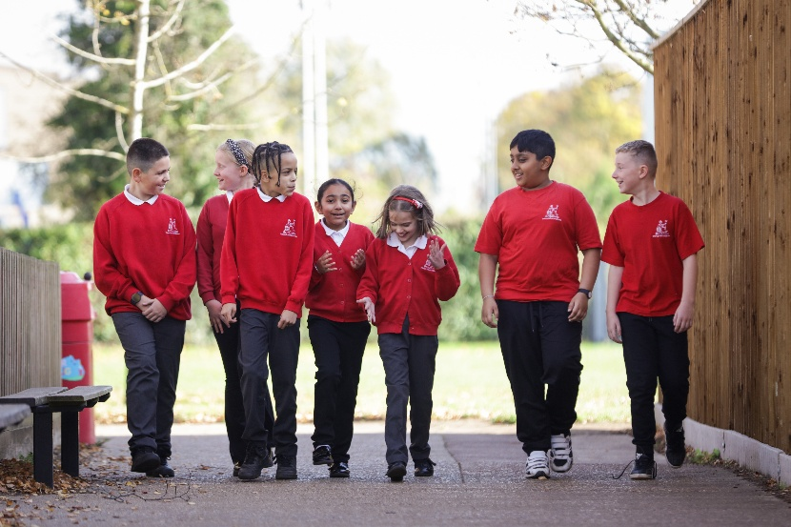

Car Parking
With the exception of disabled parking, there is no provision for parking on the school premises other than for staff and official visitors to the school.

Collecting Children from School
We would ask parents to wait for their children within the school boundary. Reception class parents should wait in the enclosed garden of the Reception area for their child. School considers that children in Years 5 and 6 may be regarded as mature enough to travel to and from school without adult supervision. All other pupils are expected to be accompanied by an adult at all times.

Dogs on Premises
Bringing dogs onto the premises can be hazardous to children, adults, and in some cases to the dogs themselves. You are therefore asked not to bring them onto the premises.

No Smoking Policy

The school has a strict no-smoking policy, and smoking is not permitted within the school boundary.

Safety in the playground
For safety reasons, all parents and children are requested not to ride bicycles or scooters within the school boundaries. Ball games are also not permitted before and after school sessions. This is due to the large number of adults and small children who may be on the premises during these times. We ask that your children are supervised by you at all times when you are with them in the playground and the school will not be liable for any injuries sustained whilst on school playground equipment before or after school hours.

Security
To ensure the safety of the children and to protect property in school, parents, governors and all visitors coming into school must report to the school office. During a visit, anyone who has signed in will be issued with a badge.

Evacuation Procedure
In case of an emergency, the school regularly practises evacuation procedures.
ATTENDANCE

The school gates open at 8.35am each day and pupils can go straight into their classroom, where their teacher will be waiting to greet them. All children are expected to arrive promptly at school by 8.50am for registration; the doors into the school building close strictly at 8.50am. If your child arrives at school after 8.50am, they will need to register at the school office.
School ends at 3.15pm. Nursery sessions are 8.45–11.45am/12.30-3.30pm.

Lunchtimes:
Reception 11.45am - 12.50pm
KS1 12.00pm – 1.05pm
KS2 12.30pm – 1.35pm

Attendance Records
We keep a record of all absences and report annually on the percentage of both authorised and unauthorised absences. If your child is absent from school due to illness, please ring the school office on each day of the absence.
The school reserves the right to authorise or not authorise any absence.
It is helpful if you could inform the school in advance, whenever possible, of appointments for doctor, dentist etc. In these cases, your child can be marked absent with authorisation on the register.
In cases of sickness/diarrhoea, please keep your child at home for at least 48 hours after the last bout.

Categories of Authorised Absence
The following reasons for absence are the only ones which can be authorised:
1) Illness
2) Emergency medical appointments
3) A day of religious observance
4) Interviews

Holidays
Holidays will not be authorised during school term time. Pupils will only be granted Leave of Absence in exceptional circumstances. The Principal will use his discretion as to whether the request for leave is an exceptional circumstance. You will need to complete a form in advance, available from the school office, and this must be accompanied by a letter explaining what the exceptional circumstances are. The school celebrates pupils who have 100% attendance with the awarding of certificates.

Attendance Officer
The Attendance Officer assists both parents and the school when children have difficulty with attendance

PUPIL BEHAVIOUR

Our aim is to develop confident, caring, self-motivated and responsible members of the school and local community. Our high standards for behaviour are outlined within our 4Rs, which link directly to our School Vision and Values.

The Four Rs:
• Respect
Treat other people in the same way you hope they would treat you, developing positive relationships that make you and those around you feel valued and safe
• Responsibility
Make thoughtful decisions on your own and take ownership of your actions
• Resilience
Be able to withstand and recover quickly from difficulty, being resourceful in the way you deal with problems and challenges
• Reflection
To pause and think about your actions and behaviour, and how it may have affected those around you.

Responsibility points are awarded for pupils who show good initiative and behaviour; these points help classes to gain Golden Time at the end of the school week.

When pupils exhibit inappropriate behaviour or attitudes in school, initially the class teacher will deal with the matter. This may then be referred to the Phase Leader or Senior Leadership Team, who will contact parents to discuss an approach to addressing the concerns. Please refer to our school Behaviour Policy for full details about how our school and parents work together to support pupil behaviour.
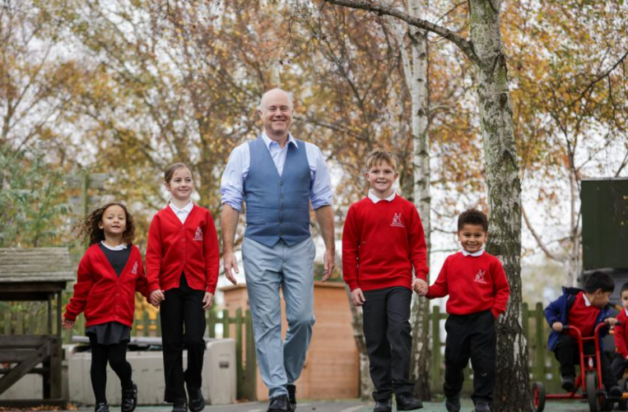

SCHOOL UNIFORM

We like all children to wear school uniform because we feel that this helps them to have a sense of belonging to the school. It costs no more than ‘fashionable’ clothes and reduces peer pressure. Please see our Uniform Policy for further information.

Our School Uniform:
- Grey or black trousers, shorts, skirt or pinafore dress (no leggings, jeans, jogging bottoms or cycling shorts please)
- Red and white summer dress (check or stripe)
- White shirt/polo shirt
- Red school sweatshirt or cardigan
- Black school shoes (no other colours or boots please)

PE Kit:

All pupils wear their PE kit to school on their PE lesson days

Britannia PE Top

Plain black shorts/jogging bottoms (no short cycling shorts please)

Plimsolls or trainers

Plain black hoodie, sweatshirt or fleece


Additional Uniform Requirements:

hair over shoulder length should always be tied back

no dyed hair

stud earrings only - no hoop or dangly earrings

no necklaces, bracelets or other jewellery to be worn

no temporary tattoos or nail varnish

Please ensure that every item is clearly marked with the pupil’s name.

It is a legal requirement for all children to participate in all aspects of physical education. Any child unfit for physical activity must bring a brief note of explanation to the class teacher, or a current doctor’s note. Extended removal from a physical activity must be accompanied by a current doctor’s note.

Wonder Wood
Pupils may wear tracksuit/jogging bottoms and a sweatshirt, plus appropriate footwear (such as wellies or trainers) on the days they have Wonder Wood.

PERSONAL BELONGINGS
All personal belongings brought into school are the responsibility of the pupil.
We ask that children do not bring money to school, unless it has been requested for a valid reason. In these cases, money should be placed in a sealed envelope and marked with the child’s name and class.
Children may bring a pocket-sized toy to school to play with during playtimes. These should be named. Any toys that may be used in an aggressive way are not acceptable. Lost property is stored in containers under the Year 1 shelter. We always aim to get any named lost property back to its owner. Any unclaimed, unnamed lost property will be sorted and disposed of/sent to charity on a half-termly basis.

FOOD AND DRINK

At Britannia we are committed to a healthy eating policy.
Children should bring water to school in a sealed, named bottle. This is kept in the classroom during the school day. Bottles can be refilled throughout the day.
An item of fruit/vegetable only may also be brought to school to be eaten during the morning break time. Pupils in Foundation Stage and Key Stage 1 are provided with free fruit or vegetables each day at school to enjoy at break times. No other snacks or cereal bars are allowed at break time. We are a nut free school.

School dinners
Meals are served in the school hall; prepared with fresh ingredients, they provide a nourishing, well balanced meal consisting of a main course, a drink and dessert, plus fruit. We serve hot or ‘cool’ meals. We run a flexible lunchtime arrangement to enable children to have a school dinner on any chosen day. Parents pay for meals online via ParentMail. All pupils in Reception and Key Stage 1 are entitled to a free school meal. However, we ask parents who are entitled to Free School Meals to still inform us, as we are able to claim Pupil Premium funding for all eligible pupils, which will be used to enhance their learning. The current price for school meals is available at the office.

Packed Lunches
Packed lunches can be eaten at school and should provide a healthy, balanced meal. In the interest of safety, fizzy drinks, including energy drinks, glass bottles and nuts are not allowed. Sweets and chocolate are not allowed in packed lunches. Please ensure your child’s lunchbox is named.

Home Dinners
If a child goes home for dinner, he/she must register on exit from the premises, this is done at the school office.

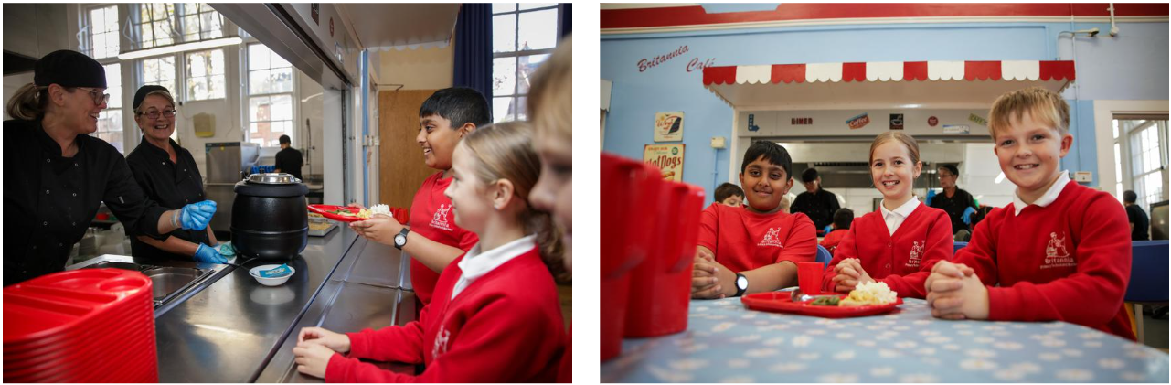

PARENTS IN PARTNERSHIP

We recognise that parents are the child’s foremost educators, and we value our partnership with you. We believe that communication is key and welcome parents to touch base with their child’s class teacher should they have any concerns at all.

Parking outside the School
Our school is situated on a very busy road and there is no parking in the school grounds for parents. Parents are able to park on Britannia Road and the surrounding side roads for drop off and pickups, but we ask you to please be considerate to the residents. Please do not park in front of their driveways, as residents need to be able to access their own property. Where possible we encourage you to walk to school with your children.

Communication
Letters and notices regarding events are posted on the school’s website and information is also sent via ParentMail. It is therefore very important that the school has an up-to-date mobile phone number and email address for you.
Please ensure that you keep us updated with this information.

Homework
All children are encouraged to read at home every day and they may be asked to find further information about a topic. Homework will be set for the older pupils and the teacher may ask parents to help their children learn spellings or multiplication tables.

Parent Teacher Consultations
Parents are invited to these meetings twice a year when they can talk with the class teacher about their child’s progress. We hope that parents will approach staff with immediate concerns at other times.
At the beginning of each term, parents receive a newsletter briefly outlining the work the children will be covering during that term. Parents have the opportunity to attend various other information meetings throughout the year.

Reports
Parents receive a full report, regarding their child’s progress, at the end of the academic year.

Britannia Friends and Family - BFF
This is the organisation which meets regularly to organise social and fund-raising events. All parents are automatically members of the association.

CHARGES

During the time your children are at school, they will have opportunities to enjoy a variety of additional activities or trips. To cover the cost of these, we often ask for a voluntary contribution from parents.
The Trust reserve the right to make a charge for activities organised by the school in the following circumstances:
- The board and lodging element of any residential activity that takes place within school hours.
- The full cost of each pupil for any activity that is an optional extra and takes place outside school hours, e.g. a residential trip, the theatre, extra-curricular clubs and performances.
- The cost of purchase or hire of instruments, materials, equipment or clothing for cooking or craft activities. The Governors may charge for materials or require them to be provided if parents have indicated in advance that they wish to own the finished product.

The Trust may amend the categories of activity for which a charge may be made. In cases of family hardship, the Trust may exempt payment for certain activities (please see the school’s Charging and Remissions Policy for terms and conditions).

THE CURRICULUM

Please see our Curriculum Policy and website pages for detailed information about our bespoke Britannia curriculum.

Assembly
Assembly takes place each week, usually in phases, and covers aspects of Cultural Capital, SMSC, British Values and Collective Worship. Assemblies focus on different aspects: the wider community, how people in the past have taught us, religious stories learning about and from different religions and religion linked to whole school curriculum teaching and learning.
The school has no affiliations to any specific religion but does have regular contact with St Andrew’s Church, Britannia Road, where members of the church lead collective worship to KS1 each month and which pupils use for their Christmas and Leavers’ productions/assemblies.
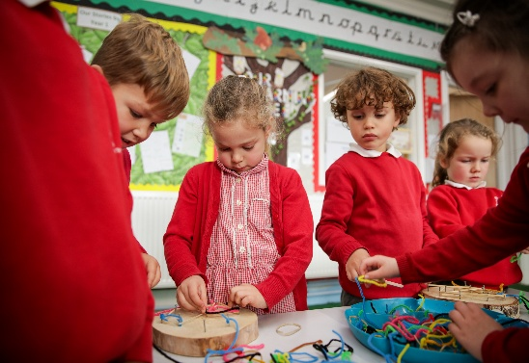
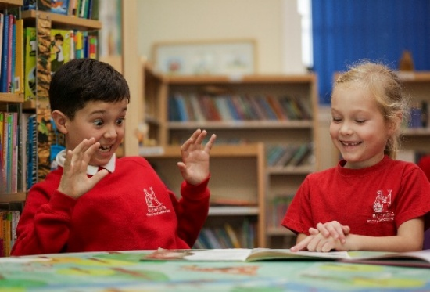

SMSC (Social, Moral, Spiritual and Cultural Education)
Opportunities to develop SMSC are within all subjects and aspects of life at Britannia. The definitions below help to describe each aspect of SMSC:
Spiritual: Explore beliefs and experience; respect faiths, feelings and values; enjoy learning about oneself, others and the surrounding world; use imagination and creativity; reflect.
Moral: Recognise right and wrong; respect the law; understand consequences; investigate moral and ethical issues; offer reasoned views.
Social: Use a range of social skills; participate in the local community; appreciate diverse viewpoints; participate, volunteer and cooperate; resolve conflict; engage with the 'British Values’ of democracy, the rule of law, liberty, respect and tolerance.
Cultural: Appreciate cultural influences; appreciate the role of Britain's parliamentary system; participate in culture opportunities; understand, accept, respect and celebrate diversity.

British Values Statement
At Britannia, we are committed to serving our community and surrounding areas. We recognise the multi-cultural, multi-faith nature of the United Kingdom and understand the crucial role our school plays in promoting these values. We encourage admissions from all those entitled to education under British law regardless of faith, ethnicity, gender, sexuality, political or financial status. This statement outlines the key British values we actively promote:
Democracy: Children are involved in democratic processes at Britannia, such as voting for School Council representatives to express their opinions and ideas. The School Council itself is led by a member of staff and adheres to the democratic processes, reporting its actions to the rest of the school. We have links to our local Member of Parliament who has come into school to talk to our pupils about the importance of democracy in action in our school.
The Rule Of Law: School has links with the local police. We have made connections with members of the local Fire Service as well as Probation, Health and Drugs services. We have a clear positive Behaviour Management policy which all stakeholders understand and follow. We regularly review behaviour incidents in school and share these with key stakeholders. Assemblies are delivered with reference to rules and laws governing both our school, the local community and the world at large.
Mutual Respect: Our RSHE curriculum embodies values of mutual respect for one another through units of learning such as Relationships and being a Responsible Citizen. All our staff, including external teaching staff, actively encourage attitudes of equality and fairness in all lessons, raising pupil understanding of the importance of such issues. Our Friendship Monitor scheme helps to foster respect between pupils across different phases when pupils are out sharing the same play areas at lunchtimes.
Individual Liberty: Pupils have key roles and responsibilities in school, such as when they are given the opportunity to take on monitoring roles within the classroom, which are appropriate to their age and level of maturity. Within school, pupils are actively encouraged to make choices, knowing that they are in a safe and supportive environment. Through our extra-curricular clubs and opportunities, pupils are given the freedom to make appropriate choices.

English

At Britannia, we follow adapted versions of the Talk 4 Writing and Talk 4 Reading approaches to teaching English. We ensure that these programmes are modified to meet the needs of our pupils. We teach phonics in EYFS and KS1 using the Read, Write Inc programme of learning.
English has a centrally important role, which extends from the subject to the wider social and cultural context. In keeping with the National Curriculum, we will develop reading for pleasure; reading comprehension; a clear focus on phonics; a focus on spelling and grammar; spoken language. In addition, we continue to use digital, online and moving image media as universally valued tools for the 21st Century, preparing children for the needs of a globalised world. We ensure comprehension, composition and creativity are valued in addition to the functional skills of decoding in reading and transcription in writing. English will be embedded across the curriculum, helping children to be aware of the role of English in relation to all subjects.

Mathematics
Similarly, we follow an adapted version of White Rose Maths throughout the school.
At Britannia we put problem solving at the heart of our mathematics curriculum, to ensure teaching is relevant, interesting and challenging for children. We nurture mathematical independence, allow children thinking time and encourage discussion. Although there is an emphasis on number in the National Curriculum, the content of the Britannia mathematics curriculum is broad and balanced. The National Curriculum states that pupils should become secure in a skill before using it to solve problems. However, we believe children can acquire, develop and practice and consolidate their learning through problem solving.
Mathematical concepts are taught using the correct language, models and images. Calculations are taught using the Britannia Maths Policy (videos for parents, regarding the school’s approach to teaching calculation can be found on the school website). Pupils are taught the programme of study relevant to their year group and teachers are encouraged not to accelerate higher attainers on to later content but to offer challenge through rich and sophisticated problems.

Science
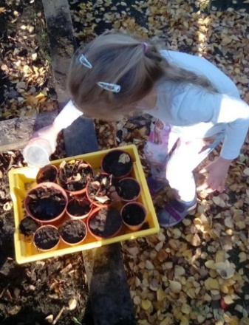
At Britannia, children will have authentic scientific experiences to engage and make sense to them. Sharing ideas is central to children’s scientific development and engaging in dialogue will develop their scientific thinking.
The outdoor environment is used to collect data, such as observing plants grow. Our outdoor classroom is key to this, as is our forest school area.
Children are taught to work scientifically, asking their own questions and making decisions using the framework of five possible approaches:
- Observing changes over time
- Looking for naturally occurring patterns and relationships
- Identifying and classifying things
- Researching secondary resources
- Comparative and fair testing.

Foundation Subjects
Our foundation subjects: art, computing, design and technology, French, geography, history, music, physical education, religious education, RSHE, are all taught through our bespoke curriculum, designed by our own subject leaders. Our foundation subject curriculum follows our bespoke Britannia Curriculum Concept approach to learning, which has a focus on long-term memory. This rich curriculum follows the National Curriculum, while focusing on the context of our school and pupils. More detail about each subject’s curriculum, examples of work and pupils engaging within these areas of learning can be found on our school website curriculum pages.

Our Wider Curriculum
In addition to the Nation Curriculum subjects, Britannia also offers a wider curriculum, including Oracy, the Wonder Wood, Global Learning and Eco Schools. These subject areas are woven into our curriculum and enable pupils to further extend their knowledge of the wider world in preparedness for beyond Year 6. Further information about all of these wider curriculum subjects can be found on our school website curriculum pages.

CHILDREN WITH SPECIAL NEEDS

We make every effort to cater for children who need additional help with their education. All Teachers work within the National ‘Code of Practice’ using the LA’s Records of Support to ensure that parents are fully involved when there are any concerns about a child’s progress.
The school’s Special Educational Needs and Disabilities Co-ordinator (SENDCo) works with all teachers to support children with short- or long-term learning needs. We utilise a range of external agencies to support pupils with special educational needs.

Admission of children with disabilities
The school welcomes pupils with disabilities where the school is able to meet the needs of the individual child. We endeavour to ensure that disabled pupils are fully integrated into the life of the school. Within the limitations of financial constraints, we will provide facilities and resources for children with specific physical needs so they can join in the full range of educational and social activities.
We ask parents of children with disabilities to arrange a meeting with the SENDCo or Principal in advance of an admission date to discuss the needs of their child and so any resource implications for the school can be assessed.
The Governing Body of Britannia Primary School and Nursery has a nominated governor who regularly liaises with the school’s Special Educational Needs and Disabilities Coordinator. The Special Educational Needs and Disabilities Governor, with the Principal, ensures that the school policy for special educational needs is reviewed and upheld.

Existing Facilities:
• Some ramped areas for wheelchair access
• Three toilets equipped for wheelchair access
• A hearing loop in the main office
• One toilet area equipped with hoist
• Visible fire alarms for hard of hearing pupils (in parts of the school)
• Lift from ground to first floor
• Two disabled car parking spaces for Blue Badge holders

PUPILS WITH ENGLISH AS AN ADDITIONAL LANGUAGE (EAL)

We have a significant number of pupils on the school roll from a range of cultural backgrounds, speaking a variety of languages.
We celebrate this cultural diversity and believe it enhances the experiences of all our pupils. All children are taught in English as the first language. For children admitted to school with minimal spoken English, we provide some support from a teaching assistant.

PUPIL ACTIVITIES

There are a number of additional club activities provided by the staff and, in some cases, external providers. Information about the extra-curricular clubs on offer is sent to parents, via ParentMail, termly.

School Council
We have a School Council led by our Principal, Mr Hart. The School Council includes representatives from Years 1-6. The children are keen to improve the running of the school and come up with some very positive ideas. Such issues as bullying, playground activities and clubs are discussed. School Councillors have the responsibility of representing their class at the meetings and their role often involves gaining the thoughts and opinions of their peers to report back.

TRANSITION TO HIGH SCHOOL

Children transfer to several high schools in the local area, but the majority go to Copleston High School for their secondary education. Close links are maintained with the High School through social and educational activities to ensure a smooth transition. The pupils will have an opportunity to visit their new High School for induction days in the summer term and High School staff also visit our Year 6 pupils at Britannia.

CARE OUTSIDE OF SCHOOL HOURS

There is a local breakfast club and after school care available each day as well as holiday clubs. These are run independently from the school by ABC Childcare, whose premises backs onto our school field. Children are dropped off in the mornings and collected from the school each day by a designated play-worker. If you wish to book your child into ABC Childcare, please phone them on 01473 718296.
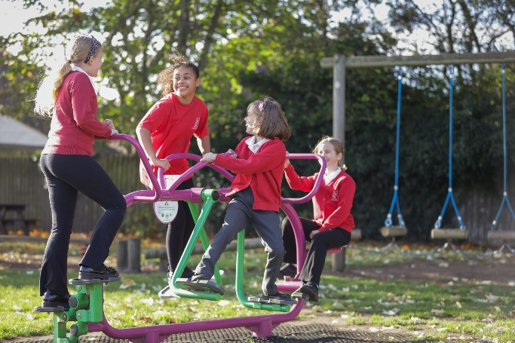

COMPLAINTS PROCEDURE
We hope your child will be happy at Britannia Primary School and Nursery. If you have any problems, you are asked to discuss these with your child’s class teacher in the first instance. The Phase Leader is next in line and if you are still not satisfied, please make an appointment to speak to a member of the Senior Leadership Team. Serious matters may be referred to the Principal.
The Governing Body is required, under section 23 of the Education Reform Act 1988, to adopt a procedure for the consideration of complaints about the school and related matters, such as Curriculum, Religious Education and Worship, the operation of Charging Policies and Regulations about the provision of information and other statutory curriculum issues.
A copy of all school policies, including the complaints procedure, is available on the school website, if you do not have access to the internet or the school office can provide you with a copy of any relevant policy you require.



